# Guidelines for Xampp setup

**Step 1: Download XAMPP**

1. **Visit the XAMPP official website**:
   * Go to Apache Friends and download version 8.1.25 or older.
   * LINK: <https://www.apachefriends.org/download.html>
2. **Choose your operating system**:
   * Click on the appropriate link for your OS to download the installer.

**Step 2: Install XAMPP**

1. **Run the installer**:
   * Locate the downloaded file and extract file if needed.



* + If you download installer.exe file then go to the file and double-click it to start the installation process.

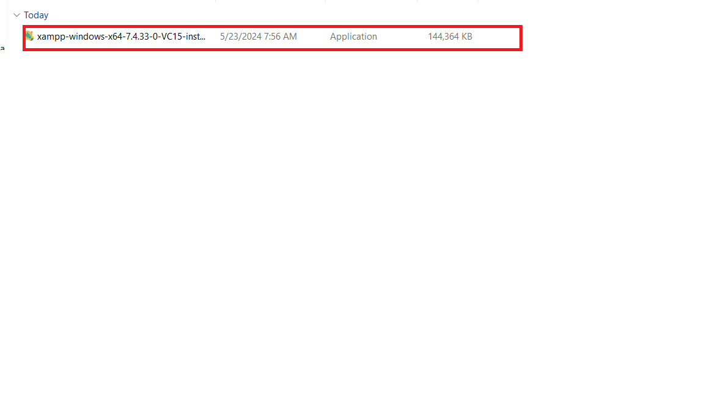

1. **Choose components**:
   * In the setup wizard, you can select which components to install. For a typical setup, you might want to install Apache, MySQL, PHP, and phpMyAdmin. Other components like FileZilla FTP Server, Tomcat, and Perl are optional based on your needs.

1. **Choose installation directory**:
   * Select the folder where you want to install XAMPP. The default directory is **C:\xampp** on Windows. Make sure your directory is C:\axxmp.

1. **Begin installation**:
   * Click the 'Next' button to start the installation. This process may take a few minutes.

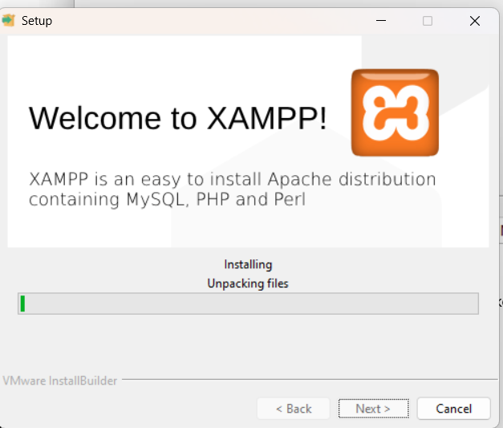

**Step 3: Start XAMPP**

1. **Open the XAMPP Control Panel**:
   * After the installation is complete, you can launch the XAMPP Control Panel from the installation directory or from a shortcut on your desktop/start menu.

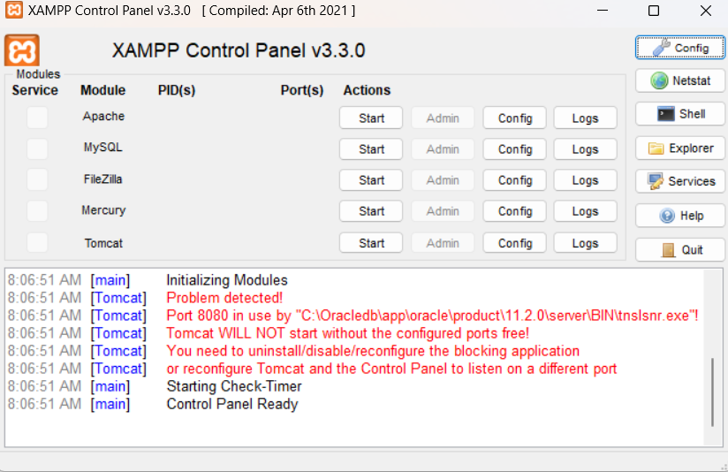

1. **Start services**:
   * In the XAMPP Control Panel, you will see options to start Apache and MySQL . Click on the 'Start' buttons next to these services. The module names should turn green, indicating that the services are running.

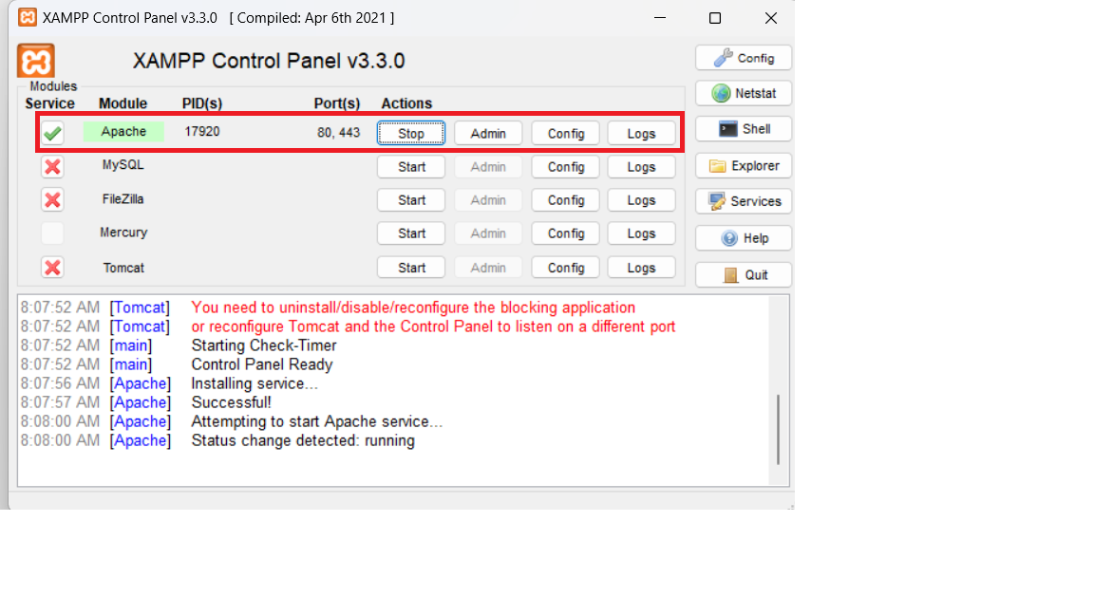

**Step 4: Configure XAMPP**

1. **Test your setup**:
   * Open a web browser and type **http://localhost**

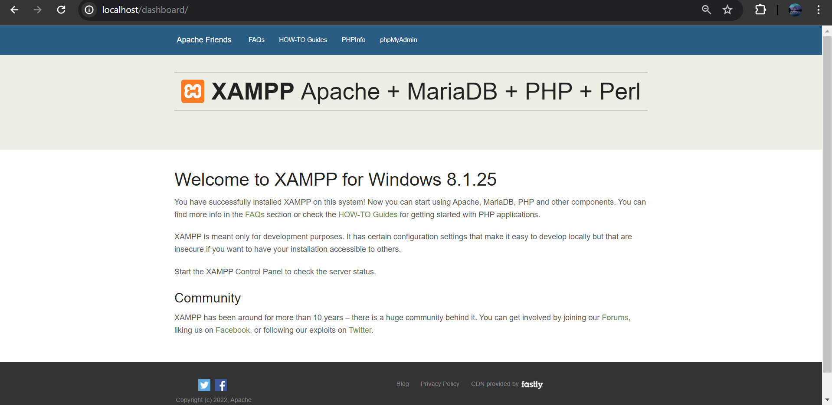

**Step 5: Accessing phpMyAdmin**

1. **Open phpMyAdmin**:
   * In your web browser, navigate to **http://localhost/phpmyadmin**



**Step 6: Deploying a Project**

1. **Create a project folder**:
   * Place your PHP project files in the **htdocs** folder inside the XAMPP installation directory. For example, if your project is named "mywebsite", create a folder **C:\xampp\htdocs\mywebsite**.

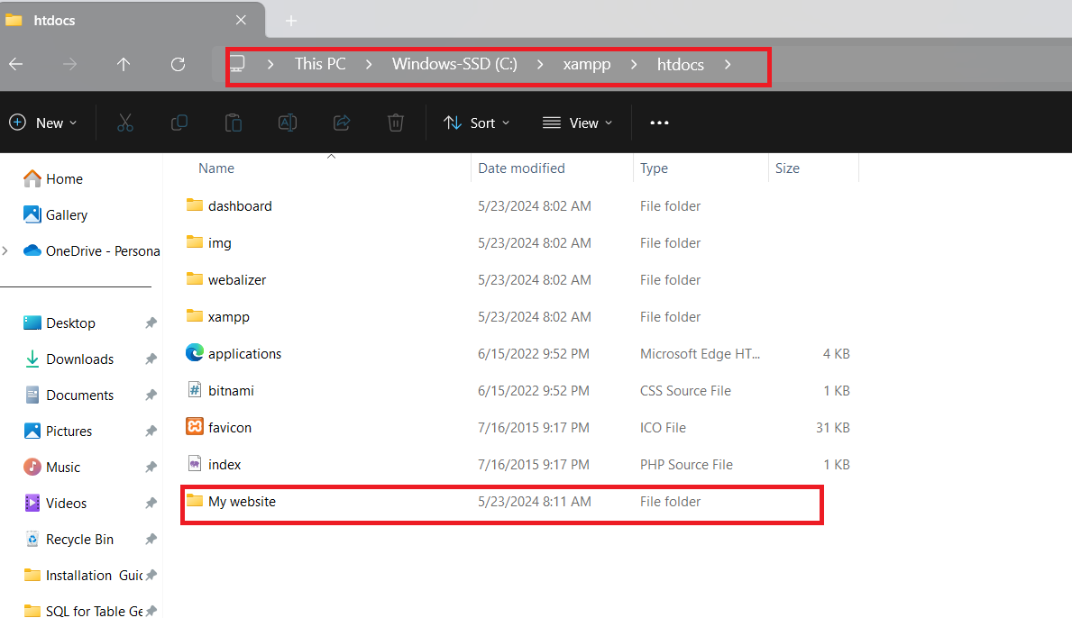

1. **Access your project**:
   * In your web browser, go to **http://localhost/mywebsite**

